Link : <http://www.studytonight.com/computer-networks/bounded-transmission-media>

**Replace** the image of the Coaxial Cable by :

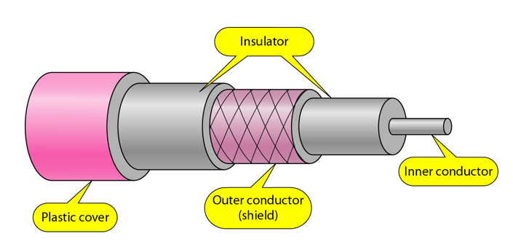

**Under: existing** Coaxial Cable **add** the following:

**Coaxial Cable Standards:**

Coaxial cables are categorized by their Radio Government (RG) ratings. Each RG number denotes a unique set of physical specifications, including the wire gauge of the inner conductor, the thickness and the type of the inner insulator, the construction of the shield, and the size and type of the outer casing. Each cable defined by an RG rating is adapted for a specialized function, as shown in the table below:

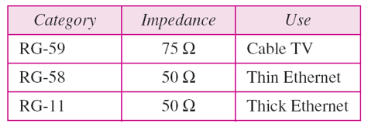

Coaxial Cable Connectors:

To connect coaxial cable to devices, we need coaxial connectors. The most common type of connector used today is the Bayonet Neill-Concelman (BNC) connector. The below figure shows 3 popular types of these connectors: the BNC Connector, the BNC T connector and the BNC terminator.

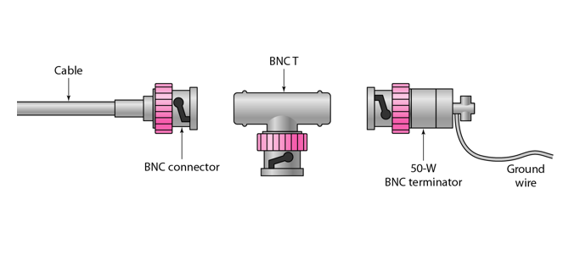

The BNC connector is used to connect the end of the cable to the device, such as a TV set. The BNC T connector is used in Ethernet networks to branch out to a connection to a computer or other device. The BNC terminator is used at the end of the cable to prevent the reflection of the signal.

**Performance:**

We can measure the performance of a coaxial cable in same way as that of Twisted Pair Cables. From the below figure, it can be seen that the attenuation is much higher in coaxial cable than in twisted-pair cable. In other words, although coaxial cable has a much higher bandwidth, the signal weakens rapidly and requires the frequent use of repeaters.

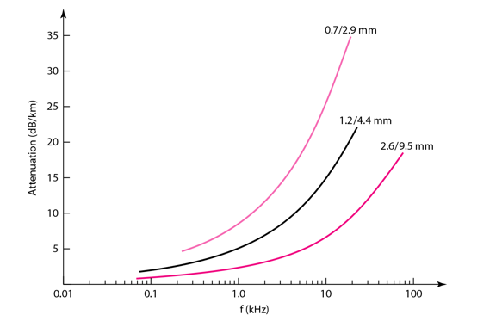

**Applications:**

* Coaxial cable was widely used in analog telephone networks, where a single coaxial network could carry 10,000 voice signals.
* Cable TV networks also use coaxial cables. In the traditional cable TV network, the entire network used coaxial cable. Cable TV uses RG-59 coaxial cable.
* In traditional Ethernet LANs. Because of it high bandwidth, and consequence high data rate, coaxial cable was chosen for digital transmission in early Ethernet LANs. The 10Base-2, or Thin Ethernet, uses RG-58 coaxial cable with BNC connectors to transmit data at 10Mbps with a range of 185 m.